Plata, Abigail

ENG 180 - 03L

November 22, 2017

Lab 4: Remote Sensing and Analysis

1. Introduction

Remote sensing generally refers to the use of satellite sensor technologies that classify objects on Earth, like the surface, atmosphere and oceans, based on propagated signals. A landsat is where satellites gather data for images of land surface and coastal regions. For instance, the landsat 8 pre-collection QA Band in specific is a created file that has values that symbolize bit-packed combinations of surface, atmosphere, and sensor conditions that can affect the usefulness of a pixel within a scene. QA bits enhance the principles of scientific research by indicating which pixels might be affected or subject to cloud contamination. The landsat bands in particular represent how the map will be displayed. For instance, in section 4.3 of this lab we use Google Earth Engine and use different bands in different combinations to present the NDVI, SAVI, and MSAVI map layers. Landsat bands can represent different things like thermal or infrared maps as well. An advantage of having information like the Earth Observation Satellite Data is to provide spatially extensive coverage that we cannot access any other way efficiently. In this lab we manipulate data in ArcMaps using ModelBuilders and the tools provided to produce tables that evaluate the differences of three Landsat spectral indices, infrared, thermal, and false color maps, and a map that displays Normalized Burn Ratio zones.

1. Methods

Section 4.1:

To begin with we download the files provided into ArcMaps. Using different color bands (red, green, and blue), from the LC080430342017070901T1-SC20171020080037 Landsat 8 tiff file we input this into the Composite Bands tool to create a raster dataset. Afterwards the data is inputted in the RGB order and the output file is called TM_432. Then we located UC Merced before saving the map by navigating to Yosemite Lake and the airport nearby Atwater, since they are two huge landmarks that can easily guide one to UC Merced.

Next we calculated the Normalized Difference Vegetation Index (NDVI) using the expression, NVDI = (NIR - Red) / (NIR + Red), where NIR would be band 5 and Red would be band 4. We are producing a NDVI raster, using the raster calculator for the July 2017 Landsat scene from the LC08_L1TP_043034_20170709_20170717_01_T1 file. Within the raster calculation we would use the float function to convert the bands into a float before inputting them into the expression. After the raster calculation we name the output tm_1707_ndvi and export this map showing the NDVI. The second raster calculation is the Normalized Burn Ratio (NBR) which is defined by the following expression, NBR = (NIR-SWIR/NIR+SWIR), where SWIR is band 7 and NIR is band 5. Similar to the previous calculation we need to use the Float function to calculate the expression. We then name this output tm_1707_nbr. Continuing with the NBR calculations, by computing the NBR this time for the October 2017 Landsat scene and using the same expression from the previous calculations, we calculate the NBR and name this output as tm_1710_nbr. Next, we need to compute the difference between the July and October 2017 NBR rasters with the equation NBR = Prefire NBR - Postfire NBR and then resulting with an output named, tm_DNbr. Afterwards, we classify the different raster calculations with a given table on Normalized Burn Ratio (NBR). Using the “Reclassify (Spatial Analyst) tool and the input being tm_Dnbr, after running it we result in an output named tm_Dnbr_cls, which demonstrates the difference between the prefire and the postfire NBR. Changing the the classes to seven and manually ending the data from Table 2 and result in a final map. Following, comparing the raster that was created for the Detwiler FIre burn perimeter that was given. In the next section we will use the Zonal Statistics tool to create statistics on different severity burn zones. The result includes the pre-fire NDVI within every severity zone, slope within every burn severity zone, and the euclidean distance from roads within every burn zone. For the Pre-fire NDVI the calculations have already been made in Section 2.1 where the output is named tm_1707_ndvi. In 3.2, using the slope tool and the NED2013 dataset that is given so that we can produce a slope raster. With NED2013_mcd_mrp_utm10, which is the same dataset that is in Lab 3, we reproject it in order to match it to the CRS of the Landsat 8 dataset. The final output for the slope raster is NED13_slope.

Next, for the Euclidean distance from Roads, we need to use the Euclidean Distance tool using the given TIGER/Line shape file for California and adding it to the workspace. To reproject the shapefile and match it to the CRS of the Landsat, we need to use the Project (Data Management) tool. The input for the Project (Data Management) tool is the prisecroads shapefile, and the output coordinate system can be found in the layers named WGS_1984_UTM_Zone_10N then resulting in a new projection. Then we reprojected this shapefile to match with the CRS, using the Raster Domain (3D Analyst). The input for this tool is one of the bands and for the output featured class type a polygon is selected which then results in an output. Following the Feature to Raster (Conversion) tool, with the input adding the RTTYP as the attribute field. Next we finally get to use the Euclidean distance tool to produce the raster output that displays distances from the reprojected road map.

Finally, we use the Zonal Statistics as Table tool in order to calculate the NDVI, slope, and distance by each burn category. Before generating any tables, we clip the NBR raster to the burn to the polygon. Next, we go to the clip tool and the input is tm_Dnbr_1 and use the ca_detwiler_20170731_0600_dd83 as the output extent. Like in section 4.2 we use the Zonal Statistics as Table tool three times for NDVI, slope, and distance, which results in the three tables as Excel files.

Section 4.2:

In the first part of this section we used the ModelBuilder under the geoprocessing tab to summarize the top ten crops in the “i15_Crop_Mapping_2014_Final_LandIQonAtlas” dataset for Merced and three other counties. We begin by dragging in the the county polygon into the ModelBuilder which is depicted by a blue bubble. Then, we use the Select tool in the ArcToolbox to help the program identify that a county polygon will be selected. The third step is done with the Clip tool where the inputs are “i15_Crop_Mapping_2014_Final_LandIQonAtlas” and the selected county polygon. This produces an output that is then used in the Summary Statistics tool. In the summary statistics tool we make sure that the field selected is Acres, the statistic type is SUM, and the Case field is Crop2014. After the summary statistics tool it’ll produce a table which needs to be sorted by the Sorted tool. The sorted tool then requires the sort field to be SUM_Acres and the Sort Method is Descending, since we are getting the top 10 crops in descending order. Finally, using the Table Select tool we pick the top ten crops in the table by using the SQL statement as mentioned above. In the SQL statement, in order to select the feature of county of interest we write an expression, “Rowid_1 <= 10,” to only get the top ten. This then produces a green bubble that has the information of the original county polygon but with only the information of the county of interest. Once the ModelBuilder is runned and everything works perfectly, it’ll ultimately produce a csv file with the list of the top ten crops of the desired county. In this lab we produce one of Merced along with El Dorado, Humbolt, and San Joaquin.

In the second part of section 4.2 it is similar to the first since we use ModelBuilder again, but this time the goal is to produce a spatial dataset of cropland use all over the world. Using the provided June 2014 landsat scene we compute the Normalized Difference Vegetation Index (NDVI), Soil-Adjusted Vegetation Index (SAVI), and the Modified SAVI Method (MSAVI) to ultimately produce the data in a table. In order to better understand the expressions needed for NDVI, SAVI and MSAVI, I used the ArcGIS website under Band Arithmetic functions. This process will require to make two ModelBuilder, where one will use another. In the first, main ModelBuilder we input Bands 5 and 4 since it contains the pixel values from the near infrared band and the red band. Using the Float tool for each band, we produce each band as a float. Afterwards, with the raster calculator we then calculate each expression (NDVI, SAVI, and MSAVI) using the bands. On the side of this ModelBuilder we then input the county polygon and do the Select process. At this point we need to make a separate ModelBuilder that will be used within this one. In the second ModelBuilder we will create a function that will accept a vegetation index and clipping feature as an input, which would: clip the feature, clip the polygon zones, and compute zone statistic. We create variables for the input input parameters and then tagging them as model parameters in order to pass inputs into them from another ModelBuilder workflow. The second function in this second ModelBuilder will compute the vegetation index and pass the result into the first function. The way I made this function is by inputting the designated county polygon that I remade for each Stanislaus, San Joaquin, and Merced and would just input the polygon into each Modelbuilder. Although I created the county polygon outside the Modelbuilder, the Modelbuilder would’ve done the same process and resulted in the same output. Then I used the Clip (Data Management) and Clip (Analysis) tool to make the index and crop clip. The index and crop clip are used for the inputs in the Zonal Statistics as Table tool. The Zonal Statistics as Table also requires a Model Parameter, Zone Field. This then outputs a table into the main model builder. Depending on what got inputted (ndvi, save, msavi) after going through the Zonal Statistics model builder it outputs a table specific for nevi, save, or msavi. Finally, we convert this table into an excel table using the Table to Excel tool. This model builder should create three tables for the selected county using the Model Builder Parameters as the inputs. In this lab I created Stanislaus, San Joaquin, and Merced NDVI, SAVI, and MSAVI tables.

Section 4.3:

In this section we will be remote sensing in Google Earth Engine with Javascript. Beginning with Landsat Visualization we are importing Landsat 8 TOA Reflectance images from January to March 2014 into the Earth Engine as a filtered image collection. In order to create a new map layer that displays the color infrared (vegetation) band combination, we make a function called colorInfrared by writing, “var colorInfrared = { min: 0, max: 0.3, bands: [‘B5’, ‘B4’, ‘B3’] };” In the colorInfrared function we use bands 5, 4, 3 in this order because it will display a map layer in infared. To then display the actual map layer we write another statement, “Map.addLayer(filtered, colorInfared, ‘RGB’);” This contains the filtered image collection, the infrared function, and the bands.

For Landsat Composite script the error was because rgb_viz was getting called and the program could not find the bands that were in the 25th percentile. Instead of using rgb_viz we write, “bands: [‘B4_p25’, ‘B3_p25’, ‘B2_p25’]” and each signify the band but at the 25th percentile. This coding eliminates any cloud coverage being displayed on the map and results in a clear sky map.

In the Band Math script, there are three different methods to create the map layers that depict NDVI, SAVI, and MSAVI. Using Method 2, where we create a function for each respected expression like, “var ndvi = median.expression("(b5 - b4) / (b5 + b4)", { b5: median.select("B5"), b4: median.select("B4")}),” After creating a proper function for SAVI and MSAVI, we then have to create a function that contains the palette color in order to differentiate them from one another. For instance, “var ndvi_viz = {min: 0, max: 1,palette:['FFFFFF','CC9966','CC9900','996600','33CC00','009900','006600','000000']};,” is the color palette for NDVI. Finally we add a map layer containing the functions for the expression, expression visualization, and name.

For the Linked Maps script once runned the maps were already linked. What made the linking a lot easier was the for loop that allowed all the maps to get linked instead of writing separate code for each map (RGB, False color, and thermal). The code is as follows: var maps = [];

for (var label in vis) {

var map = ui.Map().setControlVisibility(false);

map.addLayer(composite, vis[label]);

map.add(ui.Label(label));

maps.push(map);

}

ui.root.widgets().reset(maps)

var linker = ui.Map.Linker(maps);

The linker line of code “var linker = ui.Map.Linker(maps);,” is where the maps get linked ultimately. If one were to comment this line of code out, they would see that RGB gets displayed but the other two maps won’t be displayed properly. Although, there are other methods of linking these maps together. One way would be writing the code three times for each map instead of creating the for loop. Another method I tried was creating a checkbox where the user would check a box on which map they would want to be displayed on the screen. I wrote this code without the use of a loop.

3. Results and Discussion

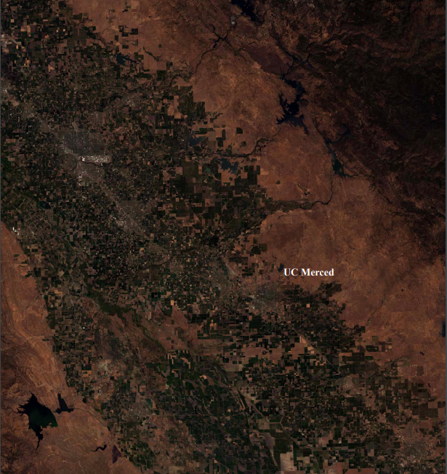

Figure 1. Map of the RGB Composite Band Layers with UC Merced labeled

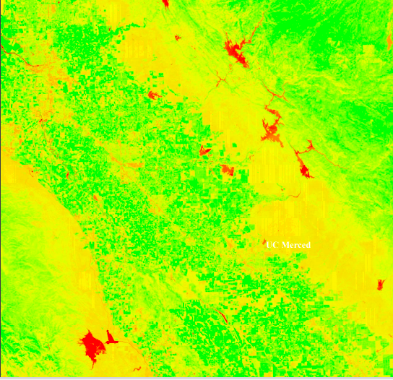Figure 2. The NDVI Raster Map of the July 2017 Landsat. The color red is representing bodies of water, whereas the green represents grasslands.

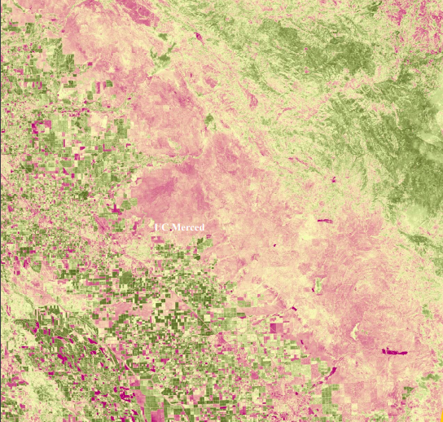Figure 3. The Normalized Burn Ratio Map. The green color corresponds with the low severity burns, whereas the pink is high severity burns.

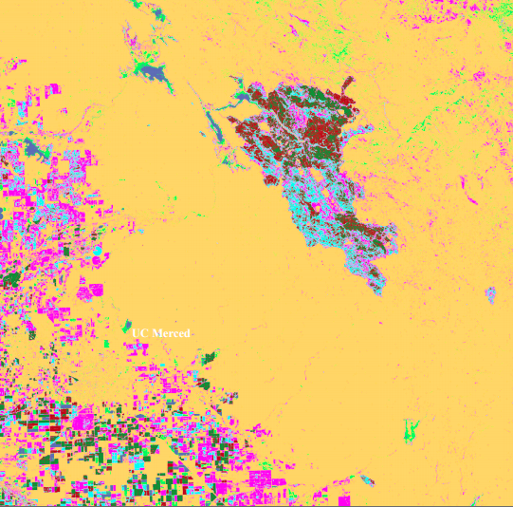Figure 4. The Normalized Burn Ratio Map of October 2017 Landsat Scene with the classification of 2 rasters.

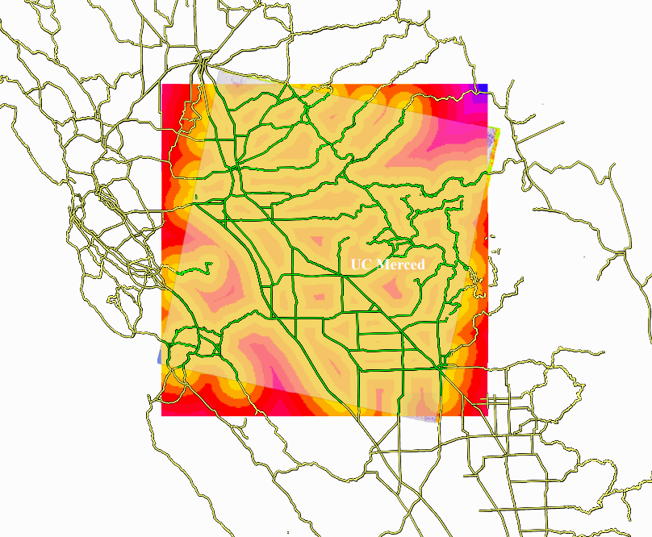Figure 5. A map representing the Euclidean distance that shows the selected road map area.

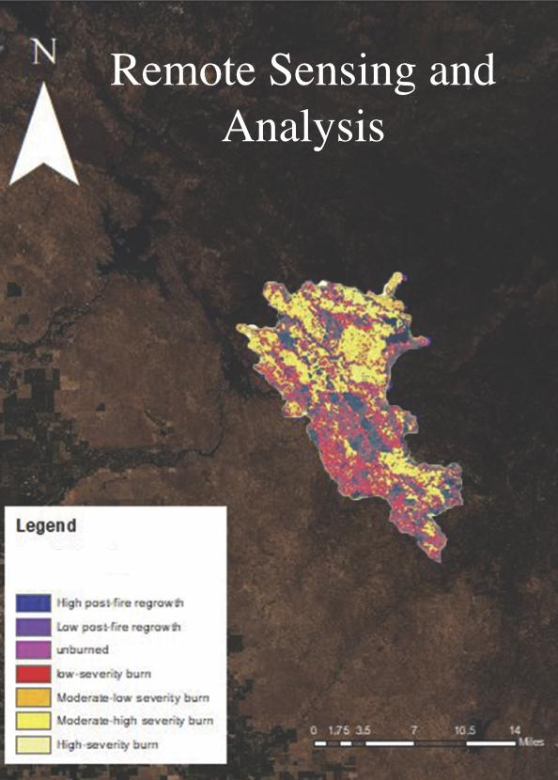Figure 6. Final map of the NBR categorized different zones of the tum_Dnbr_clip.

Zonal Statistics NDVI Table:

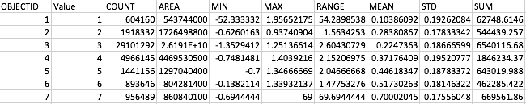

Zonal Statistics Slope Table:

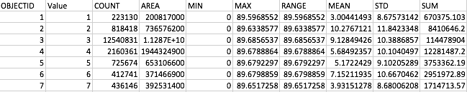

Zonal Statistics Data Table:

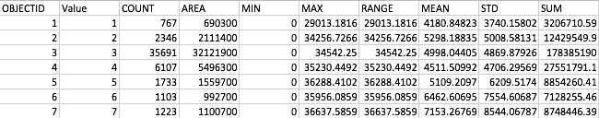

Section 4.2:

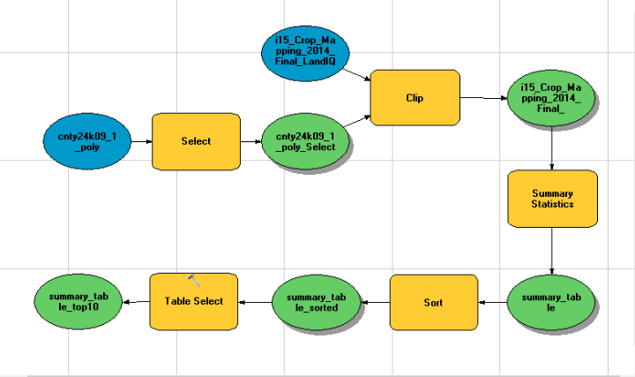

Modelbuilder that produces top 10 sum acres of crops of a selected county. In this lab I created top ten summary tables of Merced, San Joaquin, El Dorado, and Humbolt.

**Table for Merced’s Top 10:**

|  |  |  |
| --- | --- | --- |
| **CROP2014** | **Frequency** | **SUM_Acres** |
| Managed Wetland | 13 | 148935.795361409 |
| Almonds | 4262 | 128476.090317679 |
| Corn, Sorghum and Sudan | 2514 | 89522.7316941098 |
| Alfalfa and Alfalfa Mixtures | 1665 | 72189.8483422099 |
| Cotton | 934 | 38595.8101465 |
| Idle | 1524 | 38241.0649743499 |
| Urban | 23 | 30669.6086449299 |
| Tomatoes | 632 | 29043.32210303 |
| Mixed Pasture | 995 | 21754.0988512099 |
| Grapes | 388 | 17164.79143874 |

**San Joaquin’s Top 10 Table:**

|  |  |  |
| --- | --- | --- |
| **CROP2014** | **Frequency** | **SUM_ACRES** |
| Grapes | 3923 | 91619.1784609598 |
| Urban | 28 | 83790.25690983 |
| Corn, Sorghum, and Sudan | 2213 | 81488.6254641501 |
| Almonds | 2720 | 59025.29308834 |
| Walnuts | 2222 | 58709.8337426799 |
| Alfalfa and Alfalfa Mixtures | 1569 | 54767.66730145 |
| Tomatoes | 893 | 35865.3684683799 |
| Idle | 1043 | 27961.0443495999 |
| Cherries | 1347 | 18512.65420974 |
| Wheat | 384 | 17117.4903780599 |

**El Dorado’s Top 10 Table:**

|  |  |  |
| --- | --- | --- |
| **CROP2014** | **Frequency** | **SUM_ACRES** |
| Urban | 14 | 282698.665545939 |
| Grapes | 1000 | 2426.45208167999 |
| Idle | 184 | 587.771771729999 |
| Apples | 194 | 511.460272579999 |
| Mixed Pasture | 44 | 328.660947229999 |
| Walnuts | 34 | 224.9866938 |
| Flowers, Nursery and Christmas Tree Farms | 109 | 185.78575645 |
| Miscellaneous Deciduous | 61 | 125.17546483 |
| Young Perennials | 17 | 42.69750085 |
| Bush Berries | 23 | 26.7146254499999 |

**Humbolt’s Top 10 Table:**

|  |  |  |
| --- | --- | --- |
| **CROP2014** | **Frequency** | **SUM_ACRES** |
| Urban | 32 | 24864.45386378 |
| Mixed Pasture | 1299 | 18908.57911137 |
| Miscellaneous Grasses | 742 | 9415.87153804999 |
| Idle | 344 | 2391.78966576 |
| Managed Wetland | 2 | 2002.02820311999 |
| Alfalfa and Alfalfa Mixture | 17 | 262.052483169999 |
| Miscellaneous Truck Crops | 47 | 165.10609164 |
| Flowrs, Nursery and Christmas Tree Farms | 11 | 93.9060563299999 |
| Miscellaneous Grain and Hay | 6 | 77.44132184 |
| Grapes | 44 | 68.05846007 |

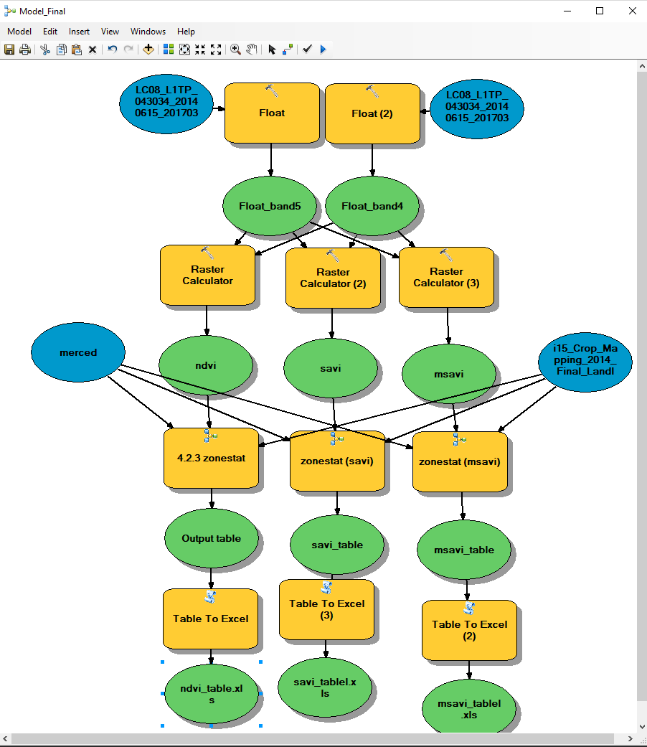

Modelbuilder that takes in two bands (band 5 and 4), converts them into floats, runs them through a raster calculator with the proper expressions (ndvi, savi, and msavi), using the designated county polygon (Merced, San Joaquin or Stanislaus), and the i15_crop_mapping_2014_final_landl file to input it into the Zonal Statistics Modelbuilder which then generates excel tables corresponding to the expressions and county.

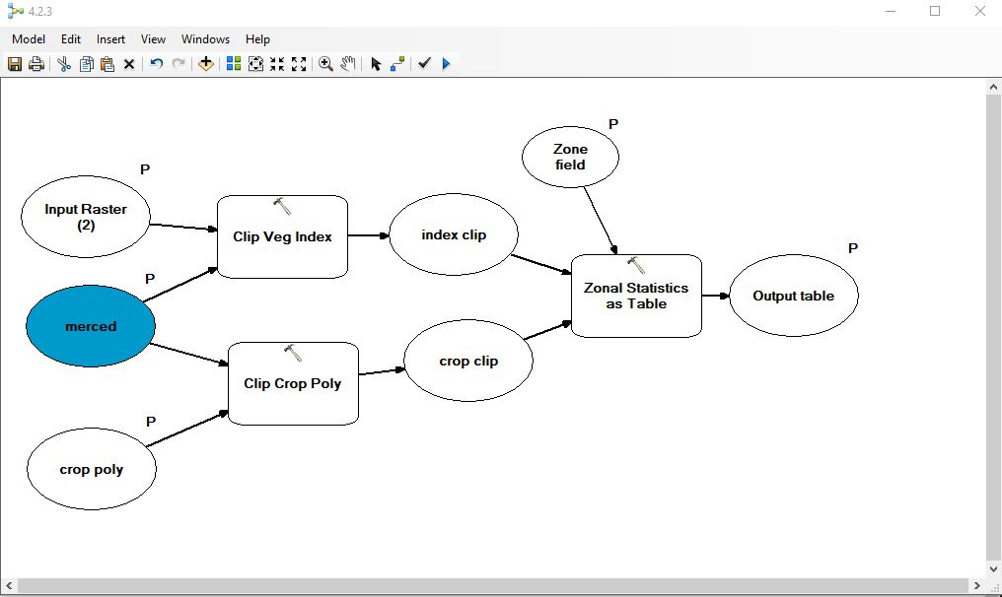

Function that accepts a vegetation index and a clipping feature as an input and would: clip the feature, clip the polygon zones, and compute zone statistics. The blue bubble is a clipped polygon of Merced county and I would change it for the desired county (Stanislaus and San Joaquin).

**NDVI Table for Merced County:**

|  |  |  |
| --- | --- | --- |
| **Crop 2014** | **Mean** | **Standard Deviation** |
| Corn, Sorghum and Sudan | 0.375757383233285 | 0.214980892765602 |
| Grapes | 0.502806136110603 | 0.147475322884345 |
| Almonds | 0.535033005976399 | 0.154303313461426 |
| Alfalfa and Alfalfa Mixtures | 0.569941873421785 | 0.193618661392298 |
| Lettuce/Leafy Greens | 0.265451058348788 | 0.0927590404894228 |

**SAVI Table for Merced County:**

|  |  |  |
| --- | --- | --- |
| **Crop 2014** | **Mean** | **Standard Deviation** |
| Corn, Sorghum and Sudan | 0.563566104946334 | 0.322433440902096 |
| Grapes | 0.754132637492809 | 0.221190877564338 |
| Almonds | 0.8024476621476 | 0.231420631616542 |
| Alfalfa and Alfalfa Mixtures | 0.854825081654662 | 0.290403558174801 |
| Lettuce/Leafy Greens | 0.398132116318852 | 0.139124153287351 |

**MSAVI Table for Merced County:**

|  |  |  |
| --- | --- | --- |
| **Crop2014** | **Mean** | **Standard Deviation** |
| Corn, Sorghum and Sudan | 0.5141478909162 | 0.206861743524502 |
| Grapes | 0.655673843232915 | 0.138489783651614 |
| Almonds | 0.682824308739418 | 0.143043951729229 |
| Alfalfa and Alfalfa Mixtures | 0.706325168790395 | 0.161158937267081 |
| Lettuce/Leafy Greens | 0.411850350460646 | 0.105534327929634 |

**Stanislaus NDVI Table:**

|  |  |  |
| --- | --- | --- |
| **Crop2014** | **Mean** | **Standard Deviation** |
| Almonds | 0.557639963029102 | 0.160308754565519 |
| Corn, Sorghum and Sudan | 0.368290125170165 | 0.211608841311569 |
| Alfalfa and Alfalfa Mixtures | 0.605477946885374 | 0.192994599054934 |
| Grapes | 0.53626639080842 | 0.170238866619498 |
| Lettuce/Leafy Greens | 0.227404165977182 | 0.0775607542410673 |

**Stanislaus SAVI Table:**

|  |  |  |
| --- | --- | --- |
| **Crop2014** | **Mean** | **Standard Deviation** |
| Almonds | 0.836356480168142 | 0.240427728364997 |
| Corn, Sorghum and Sudan | 0.552367032611043 | 0.317373599606989 |
| Alfalfa and Alfalfa Mixtures | 0.90812584536354 | 0.289467396511067 |
| Grapes | 0.804318440418518 | 0.255334581806086 |
| Lettuce/Leafy Greens | 0.341066312653801 | 0.116330082554651 |

**Stanislaus MSAVI Table:**

|  |  |  |
| --- | --- | --- |
| **Crop2014** | **Mean** | **Standard Deviation** |
| Almonds | 3250.66508298404 | 346.573774396807 |
| Corn, Sorghum and Sudan | 2908.99013304926 | 635.716091049054 |
| Alfalfa and Alfalfa Mixtures | 4020.95315141922 | 788.326869550593 |
| Grapes | 3820.48216930158 | 597.117902441306 |
| Lettuce/Leafy Greens | 2618.45192307692 | 371.719028501566 |

**San Joaquin NDVI Table:**

|  |  |  |
| --- | --- | --- |
| **Crop 2014** | **Mean** | **Standard Deviation** |
| Alfalfa and Alfalfa Mixtures | 0.664049368486131 | 0.191076080404615 |
| Almonds | 0.540873540288721 | 0.173756146590814 |
| Grapes | 0.488053863892819 | 0.122310215244109 |
| Corn, Sorghum and Sudan | 0.437261862793277 | 0.242356717696523 |
| Lettuce/Leafy Greens | 0.25204668294138 | 0.0180161940772808 |

**San Joaquin SAVI Table:**

|  |  |  |
| --- | --- | --- |
| **Crop 2014** | **Mean** | **Standard Deviation** |
| Alfalfa and Alfalfa Mixtures | 0.995974301626235 | 0.28659222175591 |
| Almonds | 0.811209427952843 | 0.260596972294086 |
| Grapes | 0.732002312665144 | 0.18344705058353 |
| Corn, Sorghum and Sudan | 0.655800492782911 | 0.363486922261159 |
| Lettuce/Leafy Greens | 0.378039313192984 | 0.0270207693596714 |

**San Joaquin MSAVI Table:**

|  |  |  |
| --- | --- | --- |
| **Crop 2014** | **Mean** | **Standard Deviation** |
| Alfalfa and Alfalfa Mixtures | 4184.78932313742 | 905.185267831416 |
| Almonds | 3195.40773244872 | 384.414705512473 |
| Grapes | 3513.24349316088 | 528.928682228024 |
| Corn, Sorghum and Sudan | 2763.49848791878 | 849.164914532892 |
| Lettuce/Leafy Greens | 3871.14179104478 | 147.071550071975 |

Section 4.3:

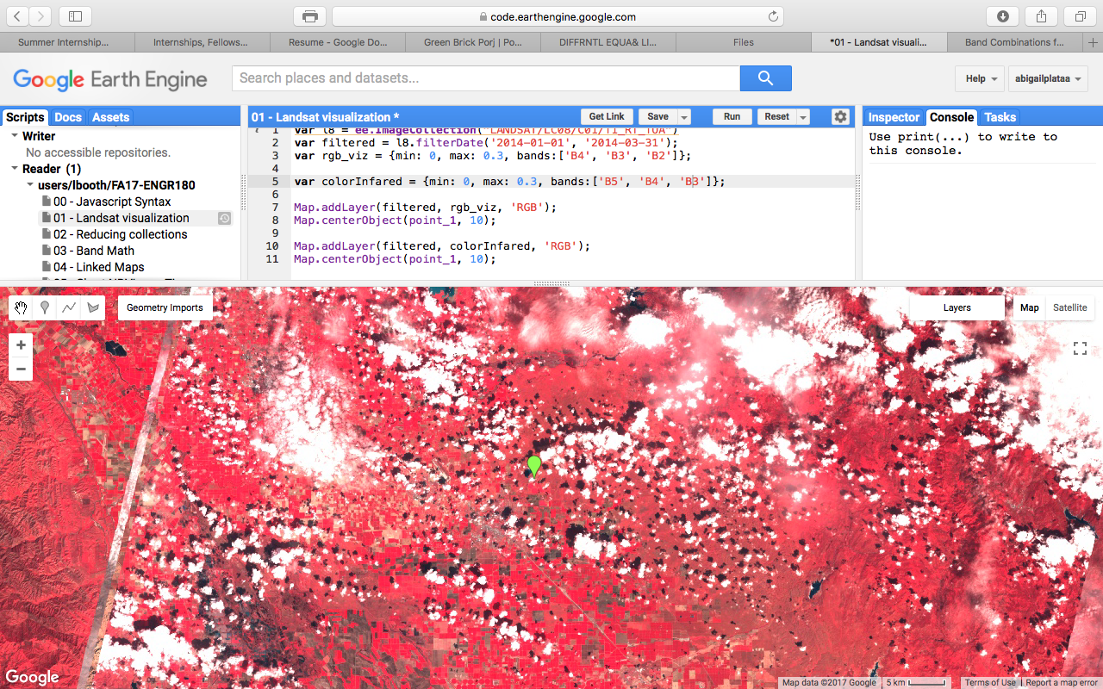

01 - Lansat Visualization Script and Map

For this section I used the Google Earth Engine API where it guides one on how to manipulate the code into producing map layers like the one above.

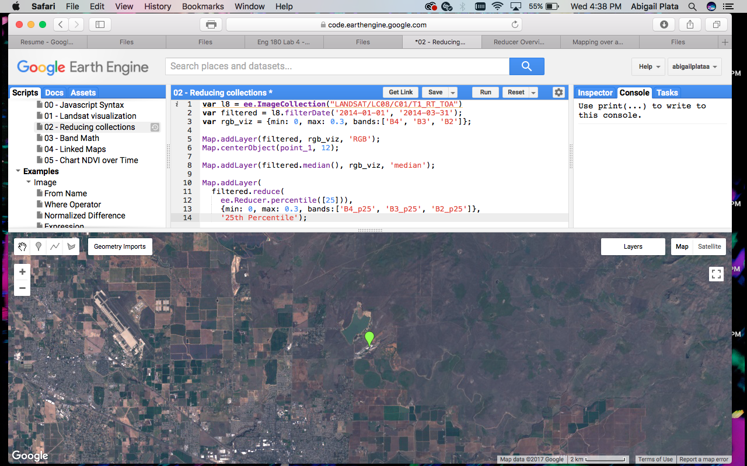

02 - Reducing Collections Script and Map

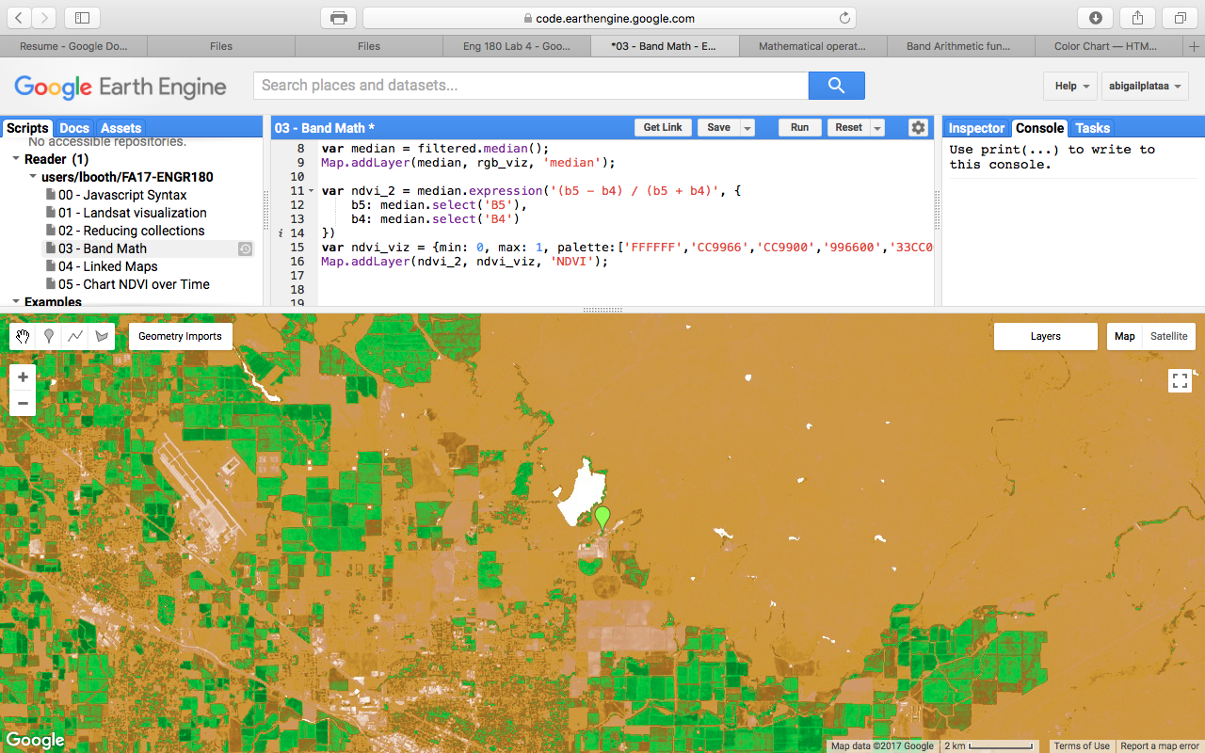

03 - Band Math Script and Map of the NDVI expression

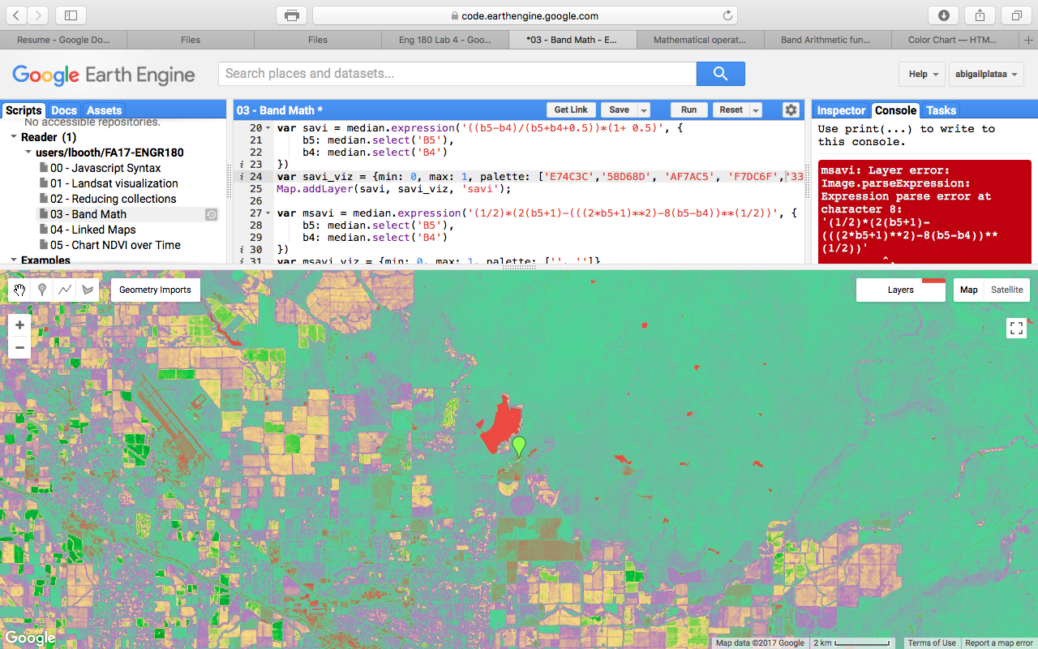

03-Band Math Script and Map of the SAVI expression

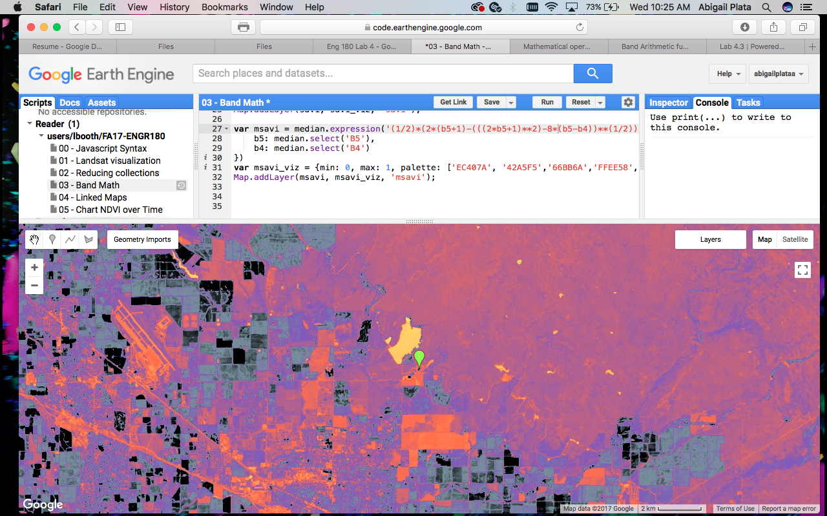

03- Band Math script and Map of the MSAVI expression

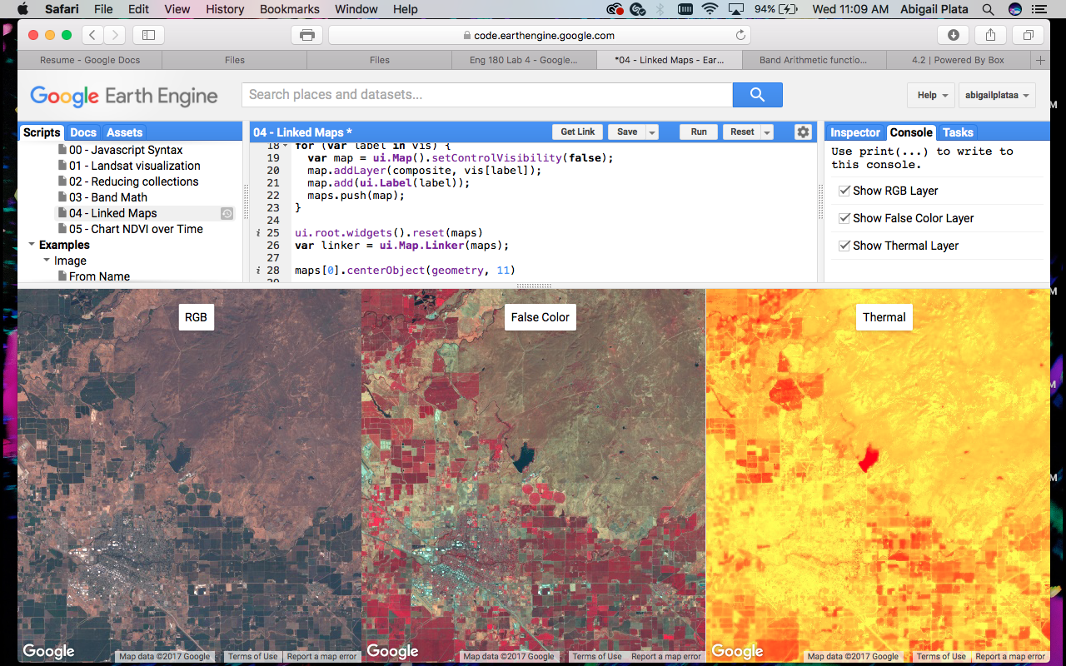

04 - Linked Map Script and map

Linked Map using the checkbox method.

References:

<http://desktop.arcgis.com/en/arcmap/latest/manage-data/raster-and-images/band-arithmetic-function.htm>

<https://developers.google.com/earth-engine/tutorial_api_04>

<https://developers.google.com/earth-engine/ui_widgets>